ГБОУ « Созвездие». Кафедра иностранных языков.

Методическая разработка учителя английского языка
Ярыгиной Юлии Евгеньевны

Конспект открытого урока в 9 классе
«Современные технологии. Роботы»

Lesson 38
Theme: Современные технологии. Роботы. Совершенствование навыков поискового чтения.
Type of lesson: урок усвоения новых знаний
By the end of the lesson the pupils will be able to:
- identify and use the main lexical units on topic;
-read fluently and understand the main contents of the text;
- understand English speech in a short documentary with a view to find the necessary information ;
-revise Future Simple ;
-talk about robots and how they can coexist with people .
Equipment: student’s book “ Spotlight 9”, different handouts, presentation, notebook , a short video.
BEGINNING OF THE LESSON
Organization moment
T: Hello, everybody! I’m glad to see you. Take your seats. Well, let’s start our lesson.
I won’t announce the topic. You know, we are starting to study Module 4 and it is dedicated to TECHNOLOGY. SLIDE 1
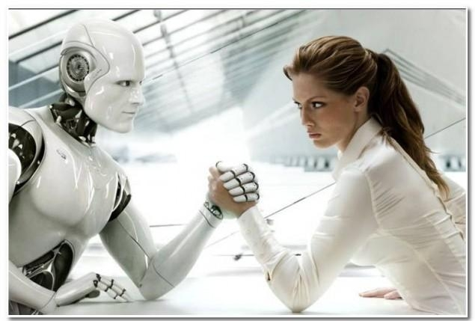
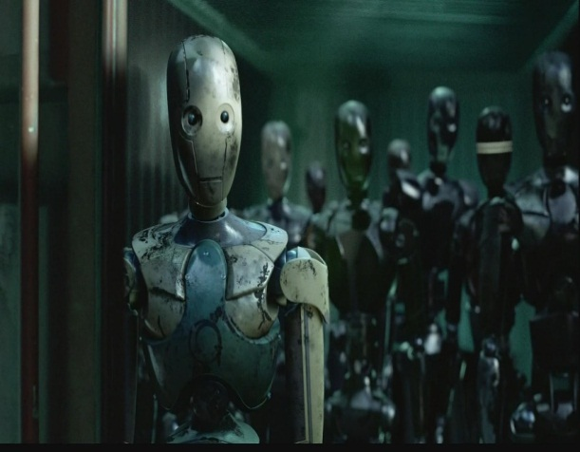
Look at the blackboard, please. What’s the topic of our lesson? Look at the pictures and guess it. ( students guess the topic of the lesson) 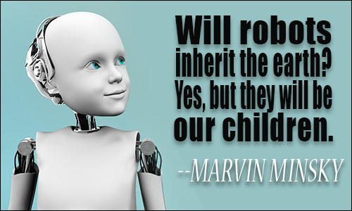

Yes, you are right.
SLIDE 2 It’s ROBOTS. By the end of the lesson you ‘ll be able to talk about the role of robots in our life using the information from the text for reading.
And how will we work? Let’s discuss the plan of our lesson.
SLIDE 3

Warming up

Pay attention to Marvin Minsky’s quotation : “Will robots inherit the earth? Yes. But they will be our children”
SLIDE 4 Do you agree with these words?
( students tell what they think about these words)
SLIDE 5 Now I propose you a poem about a robot.
I’m a ROBOT
A ROBOT am I.
Computer for brains
And camera for eyes.
I’m metal and wires,
Not muscle and skin.
I’ve no larynx for talking ,
But a speaker built- in.
(students read, discuss, get task to learn by heart for the next lesson) +copy of the poem for each student
MAIN PART OF THE LESSON
Speaking
SLIDE 6
Let’s discuss what robots can do. Look at the slide, think and start your speech like this :”I think robots can…, but…”
(students talk,then write down their thoughts into copybooks)
SLIDE 7
Good for you! Now tell me what robots possess/show. Then write down your ideas.
Reading
( while- reading activity)
SLIDE 8
Open your books at page 58 . You are proposed to read the text “Where are the robots?” While reading we’ll fill in the missing phrases and write down correct answers into our copybooks.
(after – reading activity)
Answer the questions orally:
- Name the writers who wrote about robots.
- Have we got any robots nowadays? Give examples.
- Do scientists have knowledge to give robots intelligence and the power of reasoning?
- What can Honda’s ASIMO robot do?
- Do you believe that soon household robots may be as common as home computers?

Dynamic break
Running Dictation ( using the lexics of the lesson)
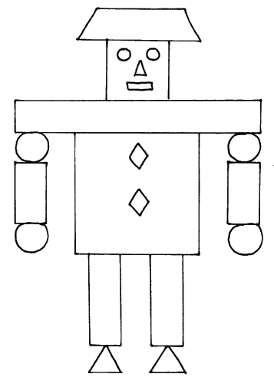
Listening
Listen and watch the video. Answer my question : What is special about Kirobo?
Blasted- зд. стартовал
Compassion- жалость, сострадание
( students listen for the second time)
After- listening task :
AGREE OR DISAGREE WITH THE STATEMENTS: (work in pairs)
1.The report is about Chinese latest astronaut.
2.Kirobo was exposed to zero gravity before being blasted into space
3.Kirobo’s destination is the International Space Station.
4.The android has been sent into orbit alone without humans.
5.Kirobo can’t mimic human emotions.
6.The creator of the robot wants its sense of compassion to help lonely astronauts during their stay in space.
Revising Grammar (Future Simple)
SLIDE 9
Translate the following sentences using Future Simple and words of Lesson 4a:
1.Роботы будут нашими помощниками.
2.Он будет копировать жесты человека.
3.Умные роботы станут реальностью очень скоро.
4.Машины будут просто подчиняться нашим приказам.
5.Ракета стартует в космос через месяц.
6.Ученые решат проблему искусственного мозга в ближайшем будущем.
Summing up and introspection
SLIDE 10
In groups draw a robot. Name it. Say what your robot can/ can’t do. Draw a smile on its display (face ) if you liked the lesson or a sad expression if the lesson was useless for you.
( Students draw , then present their projects)
Self- rating and marks for the lesson:
SLIDE 11
Students analyse their work using the pictures, then the teacher appraises students’ work:

Hometask
V-1: ex. 6 p.59-make phrases,then use them in your own sentences
v-2: ex.7 p.59- choose the correct word

